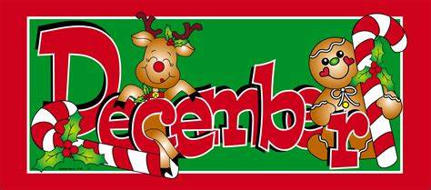

**Please see the NEWSLETTER below**

**for upcoming school events in December!**

**Hello Parents & Guardians!**